Strategy Guide — Cyber use of this procedure
The procedure is: check logistic assumptions → fit a binary logit → move the threshold → read the ROC → handle class imbalance. It is a scoring workflow, not packet forensics and not a causal study of attackers.

When this package is the right next step
- The event is a clean 0/1 (phish / not, brute-force / not) and you can name the costly error.
- Features are numeric or flags, and you expect a roughly linear log-odds.
- You want coefficients a detection engineer can read in a design review.
- n is hundreds+ and the minority class still clears ~10 events per planned feature.

Top 10 cybersecurity applications
- Phishing / malicious-URL scoring on a mail or web gateway.
- Account-takeover or brute-force detection from session features.
- Malware vs benign on a short static-feature scorecard.
- SIEM alert triage — promote or demote a rule hit before it pages someone.
- DLP / exfil first-pass on destination rarity + bytes + off-hours.
- Vulnerability prioritization (exploited-in-the-wild vs not).
- Business-email-compromise flag from reply-to mismatch + urgency counts.
- Insider-risk screen from badge / print / USB counts (human review required).
- Bot vs human on a login page using coarse behavioural proxies.
- Cloud misconfiguration ‘will this public bucket be abused’ using exposure flags.

When it is not appropriate
- Multi-family malware taxonomy — not a binary problem.
- Repeated beacons from the same host or campaign — independence fails.
- Twelve confirmed APT incidents and forty features — EPV collapse.
- Raw PCAP or payload bytes as columns — learn a representation first.
- Causal claim that a control “caused” fewer phish — this is a risk score.
- Streaming concept drift with no periodic refit — coefficients go stale.
- Highly non-linear C2 patterns — trees or sequence models.
- Time-to-compromise or dwell time — use a survival model.

How to reuse the template
Open LogReg_Cyber_Reusable_Template.ipynb. Change DATA_PATH, TARGET, POSITIVE_MAP, FEATURES, ID_COL, THRESHOLD. Run the assumption cells before you celebrate the AUC. Copy the simulation cell when a CISO asks “what if we only labelled 200 events?”.

Responsible use
cyber_phishing.csv is a teaching proxy generated so the lesson numbers are stable. It is not last week’s gateway log and it is not a licence to auto-block staff mail. Thresholds belong to the people who own the miss budget and the ticket queue. Write “decision support, not a verdict” on every memo that leaves the classroom.
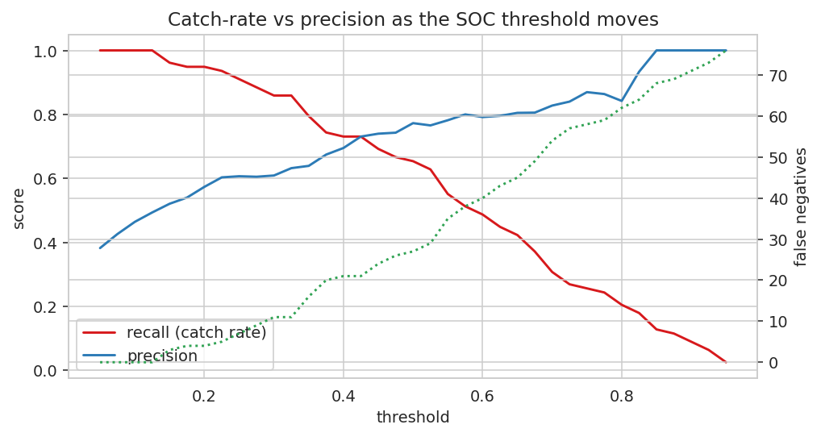
Catch-rate falls and precision rises as the cut moves right; missed phish (dotted) climb. That picture is the whole SOC policy conversation.

